|  |  |  |  |  |  |
| --- | --- | --- | --- | --- | --- |
| Date | 13-Dec-22 | | | Tester Name | Mayuri Patel |
| Environment | Penfax - Test | | | Login used |  |
| Operating System | Select OS | Version: | Update: | | |
| Software Used | Select Software | Version: | Update: | | |
| Select Software | Version: | Update: | | |
| Release version | 22.4.1 | | | | |
| Title |  | | | | |
| Test Type | Regression | | | | |
| Test Scenario | Process PEBA Monthly Payroll Report | | | | |
|  |  | | | | |
| Expected Results |  | | | | |
| Pass/Fail | Pass | | | JIRA# | N/A |

Describe your steps with screenshots:

Search for Monthly PEPP Payment production Batches

Select Processed Monthly batch that is relevant

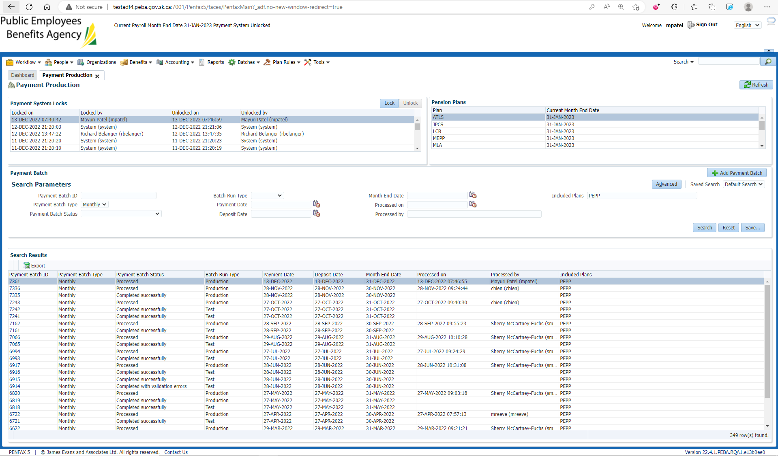

Under the selected payment Batch 🡪 Benefit Payments, members are listed whose payment is processed

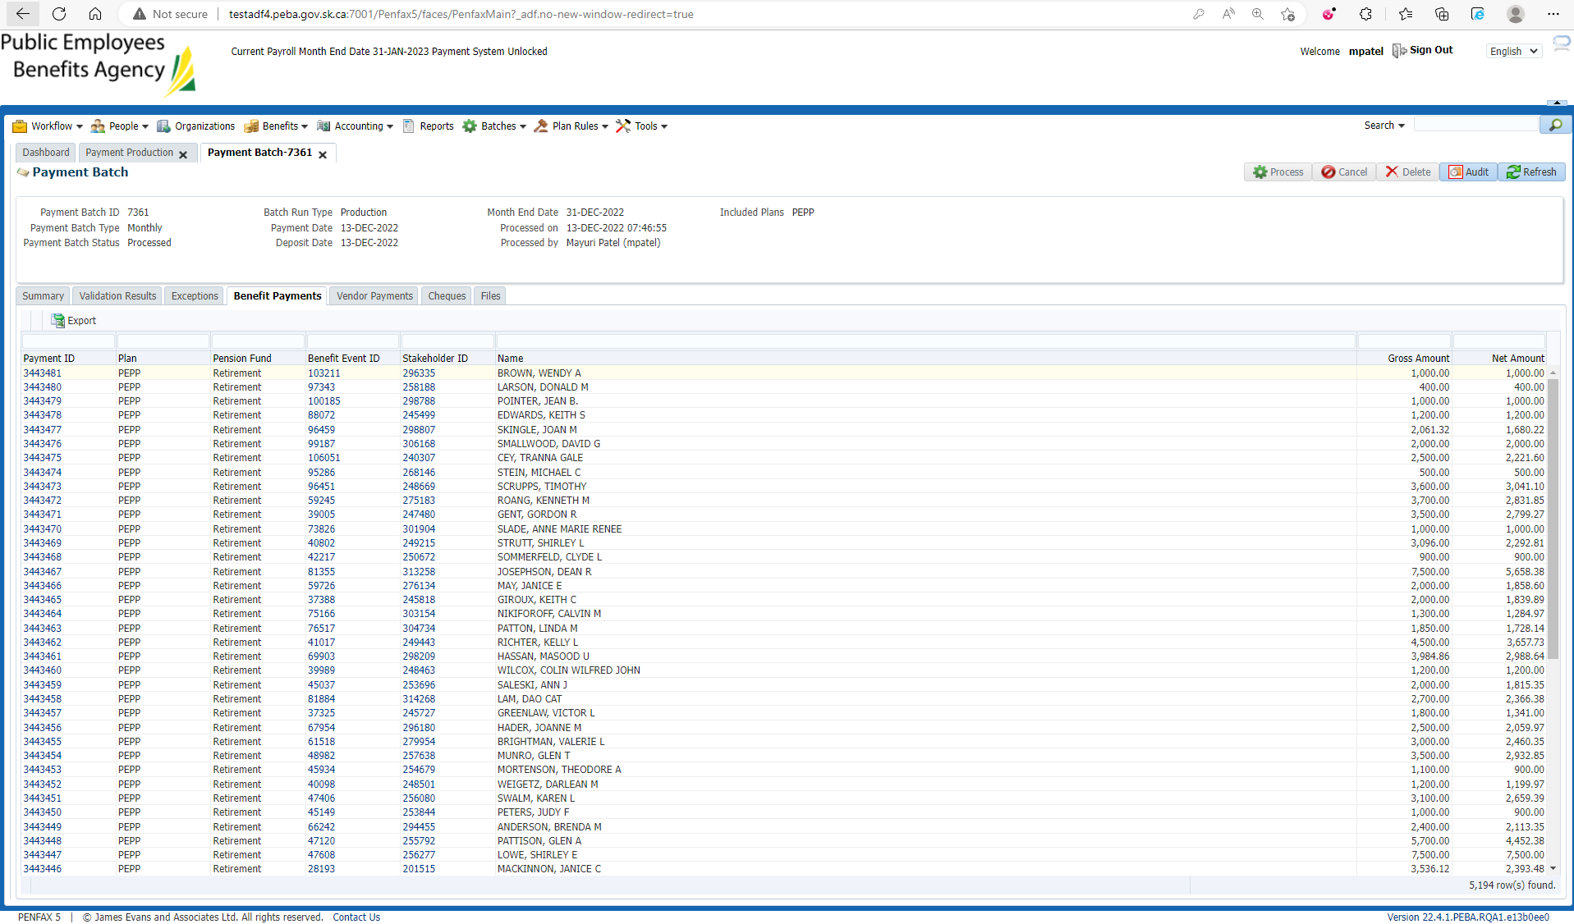

Randomly choose any member to see if Payment is received under Income benefit under Benefit Recipient

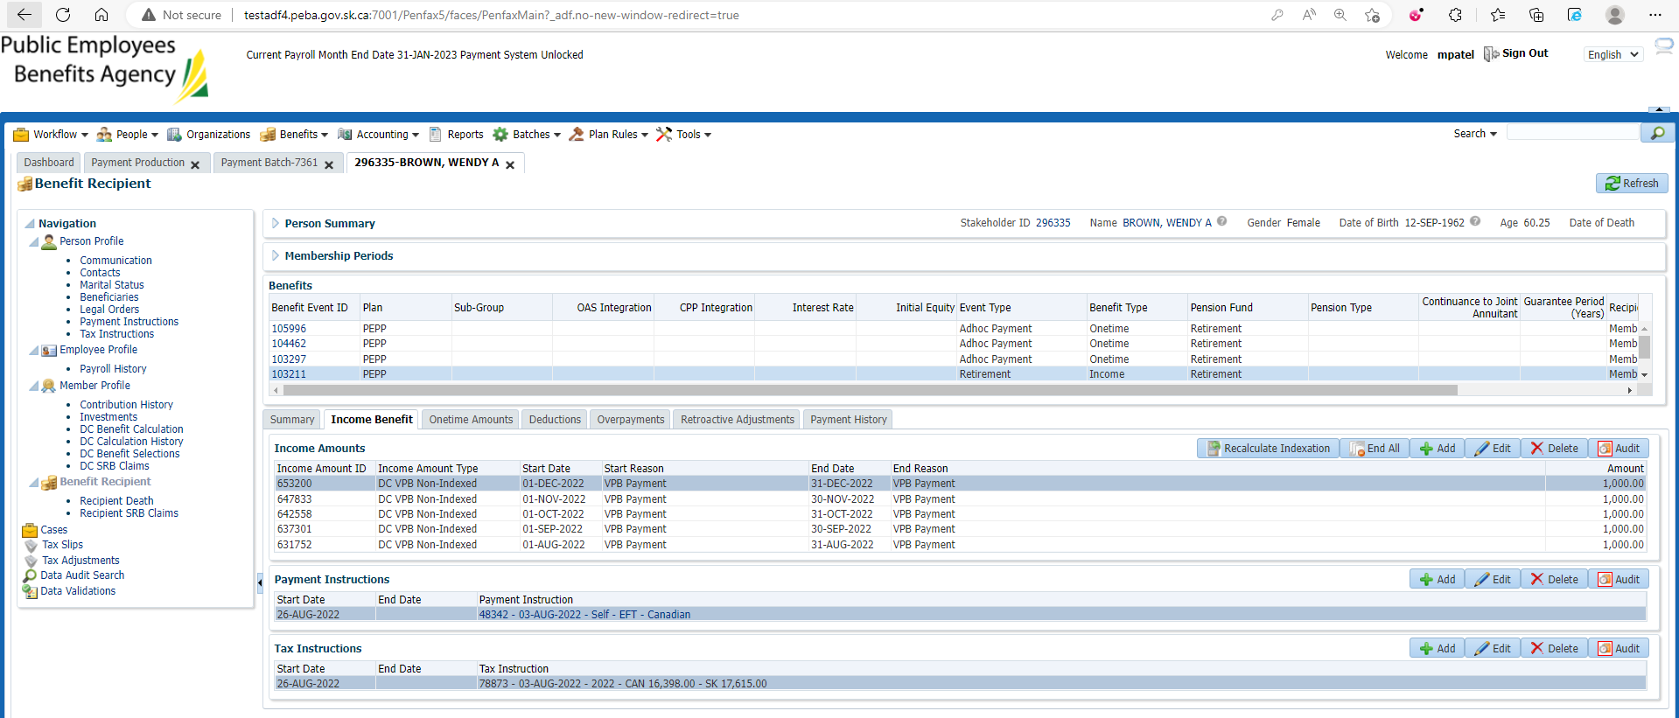

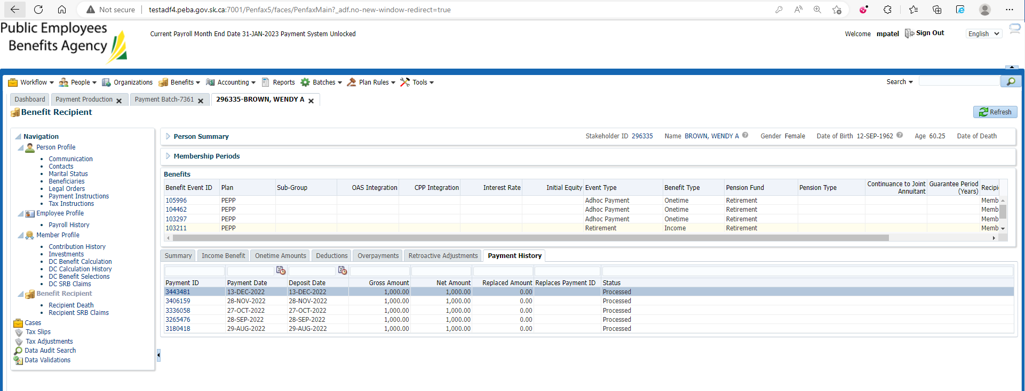

Likewise verify for other members as well

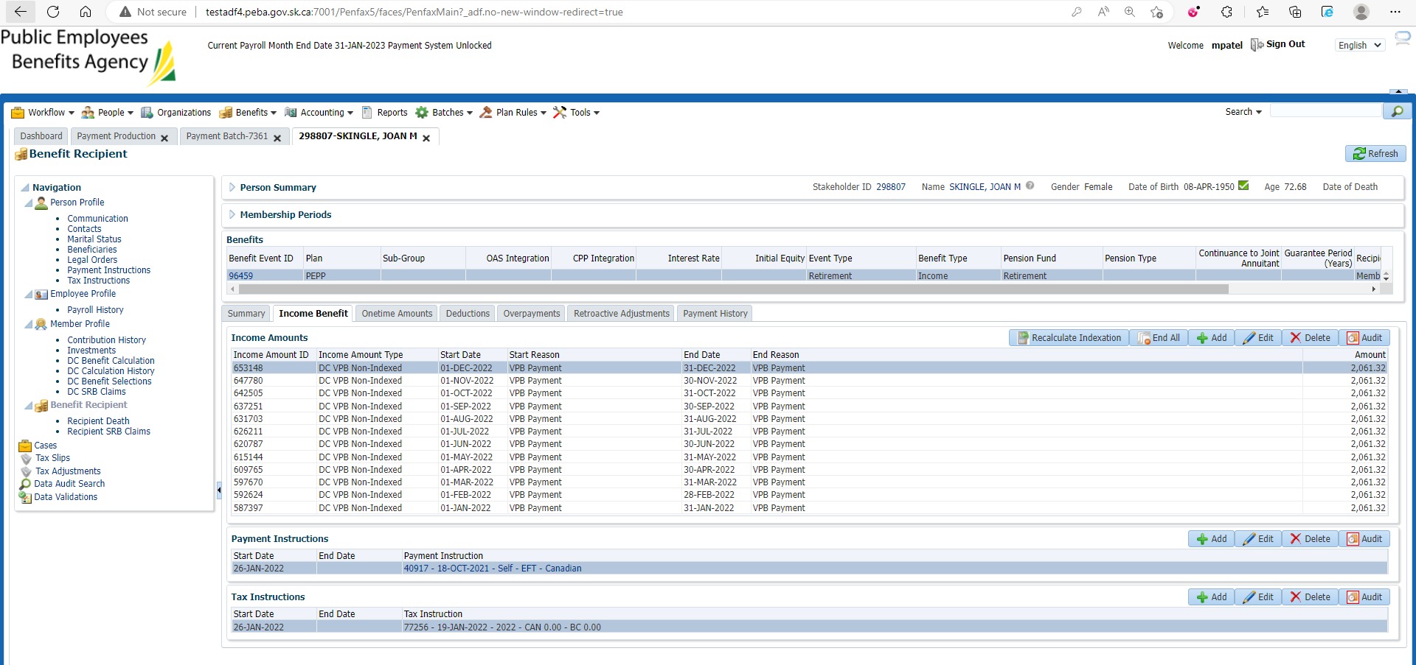

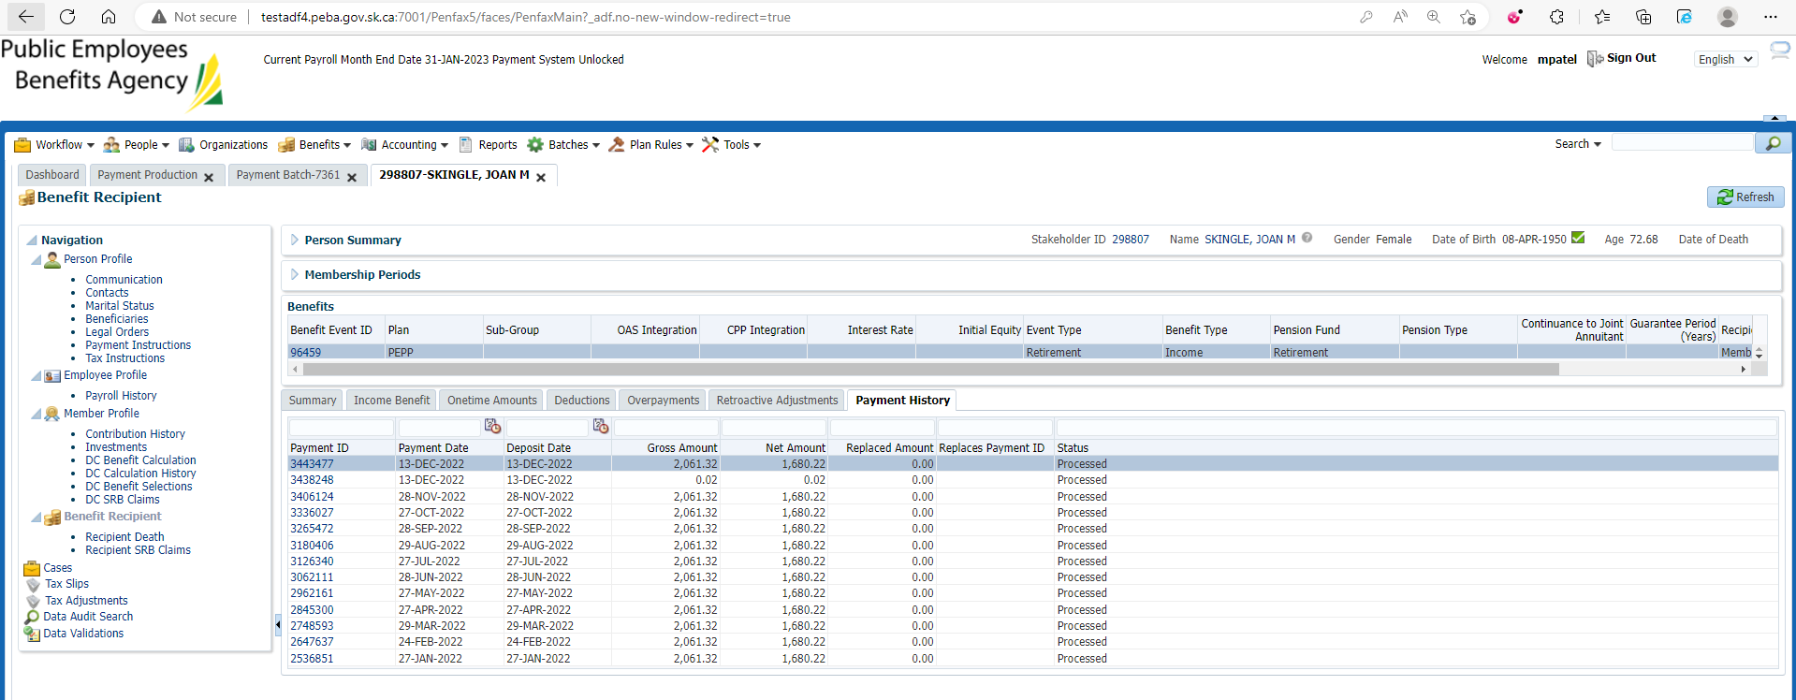

Members with payment instruction as self cheque are found under cheques tab under that Payment Batch

